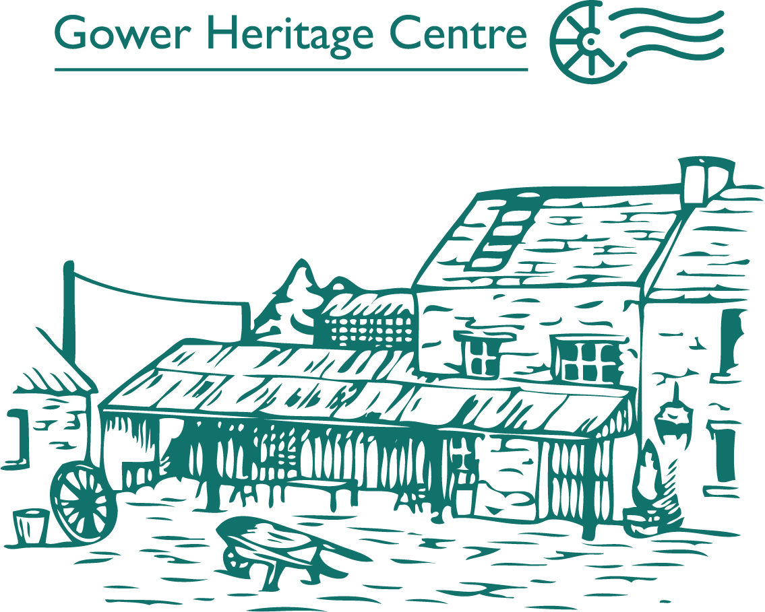

Group Travel Information Pack

Our 12th century working water-powered corn and saw mill complex is a Wales Tourist Board Star Attraction and we aim to provide a complete service for visiting groups, from the moment you book your visit with us. You can choose from a range of possible options such as Guided Tour, Guided & Themed Walks, Welsh Cream Tea, Meals and Extra Activities. Each tour can be geared to your specific needs. We look forward to welcoming you to Gower.

CONTENTS

- Useful information – How to get here & Accessibility.
- Guided tours– what we can do for you.
- Meals & Refreshments
- Guided Walks
- Extra activities
- Commendations
- Booking and prices
- Familiarisation visits

1. Useful information

How do we get there?
The Gower Heritage Centre is on the A4118 only 8 miles west of Swansea in the village of Parkmill. There is ample coach parking at the Centre; just follow the brown tourist signs into the main car park.

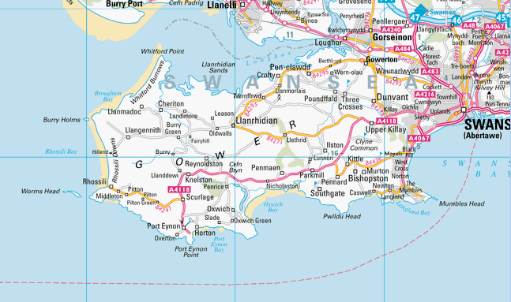

Accessibility
The Gower Heritage Centre is particularly convenient for visiting groups who have mobility problems. Wheelchairs can be used throughout the site, although we also have 3 available for your use. Contact us to discuss your requirements.

How long does a visit last?
Most group visits last two hours. Our guided tours take about half an hour. Your group will also want at least half an hour to look around the rest of the site and enjoy our craft shops. Workshop activities usually add another hour to your stay. This can be extended to a full day visit if you wish to combine it with a guided walk.

2. Guided tours

Guided tours are available every day. The minimum group size is 10, maximum 150, although a large party would be broken into smaller groups.

You are greeted at the entrance by your Guide, who will direct the group to the Water Wheel to begin the tour, which will take between half an hour and 45 minutes. It will take you all round the water-powered corn mill and saw mill, into the Miller’s cottage and Blacksmith’s shop, and include the history of the Mill and descriptions of milling, wood-turning and blacksmithing. There are plenty of chances to ask and answer questions. The tour also takes in the coracle display area. Following the tour, your group will want to investigate the rest of the site. As well as the traditional crafts and shops, there is a collection of rare breeds of poultry and ducks.

At the “eggucation centre”, there are often tiny chicks that have just hatched. There is an impressive collection of old farming machinery, with the old threshing machine regularly put to work. Older visitors may be taken back in time if they visit the air raid shelter, with a collection of wartime memorabilia. We organise special visits for school and college groups, which include a tour of the Heritage Centre and worksheets. Please ask for our School/College Group information packs.

3. Meals and Refreshments

Our Tearooms offer a variety of traditional and homemade hot and cold options. From soups or full lunches to light snacks and our famous Welsh Cream Teas. You can also have the chance to taste our award winning Cider & Perry brewed at the Mill from our own Apples and Pears grown here in the Orchard. We can also prepare a menu package to suit your needs.

4. Guided Walks

The Gower peninsula was the UK’s first designated area of outstanding natural beauty and is an ideal location for walking tours. Nearby Green Cwm valley with its Neolithic burial chamber, lime kiln and prehistoric cave, or Three Cliffs Valley with rare flora & fauna and overlooked by the ruins of Pennard Castle, are ideal destinations for a guided walk. They are easily accessible on foot from the Gower Heritage Centre and we can design the walk to fit in with your group’s abilities, lasting 1 or 2 hours or longer if required. Please contact us for further details about a themed walk (history, nature, “in the footsteps of the Saints”).

The Gower Heritage Centre is accredited by the Wales Tourist Board as an Activity providers and all walks are accompanied by a B.E.L.A. qualified guide. Our guides are trained to Basic Expedition Leader standard and are qualified First Aiders with full insurance cover as required by the British Sports Council.

A Cream Tea Gower Tour, by coach, is also available for groups. A fully qualified guide will accompany the visitors, on their own coach, to point out the highlights of Gower: from the heights of Cefn Bryn and the historic “Arthur’s Stone” to the breath-taking beauty of Rhossili beach and the Worm’s Head, returning to the Gower Heritage Centre for a traditional Cream Tea.

5. Extra Activities

Flour Making Your group can watch flour being made in the 12th century corn mill, and try using a hand corn grinder. Each visitor will take home a small bag of flour.
Pottery Our resident potter will help members of your group to “throw their own pot” (for small groups) or make clay models. These can be taken home on the day.
Woodturning Discover how chair legs were made and have a go on the foot operated pole lathe. During the workshop, your group will be able to make their own eggcups or key-fobs.
Blacksmithing Your group can learn about the importance of the smith in traditional society and watch our blacksmith fire up the forge and make metal items.
Welsh Coracle Your group will be told about the history of this very old form of water transport and its links around the world. Following a demonstration, some members may like to have a go.
Youth Groups & Schools There are a variety of other activities and workshops which are designed for younger visitors. Please contact us for one of our specialised information packs.

6. Commendations

What some of our visiting groups have said:

“Everyone has had fabulous and enjoyable day, thank you.”
Nant Coch Sunday Club

“Thanks for all the pleasurable time had by all over the season.” SAGA Reps Roger, Robin, Dee & Jenny.
“How much our party enjoyed our visit…You have certainly built up a most interesting site – and your Welsh Cakes were a treat.” Sue Ryder Care

“Da iawn! Very interesting and a great couple of hours we spent with you”
Garnswllt OAP day out

“Fully deserves all the awards and accolades it has been given.”
Grant Morris

6. Booking Prices

Please telephone the Heritage Centre on 01792 371206 to check availability on your chosen date. We will confirm with you the overall price for your chosen option.

Group Prices are as follows per person:

Entry & Guided Tour of the Centre £5.50
Seniors £5.00
Coach Tour of Gower or Guided Walk from £7.00

One Tour plus workshop £7.00
Any Tour plus Cream Tea or Cawl* £9.95
(*Cawl: Traditional Welsh lamb broth)

7. Familiarisation Trips

Please enjoy a free visit. Just call us today and book a planning visit.

